#
# 20180427
# SD#1262100
#

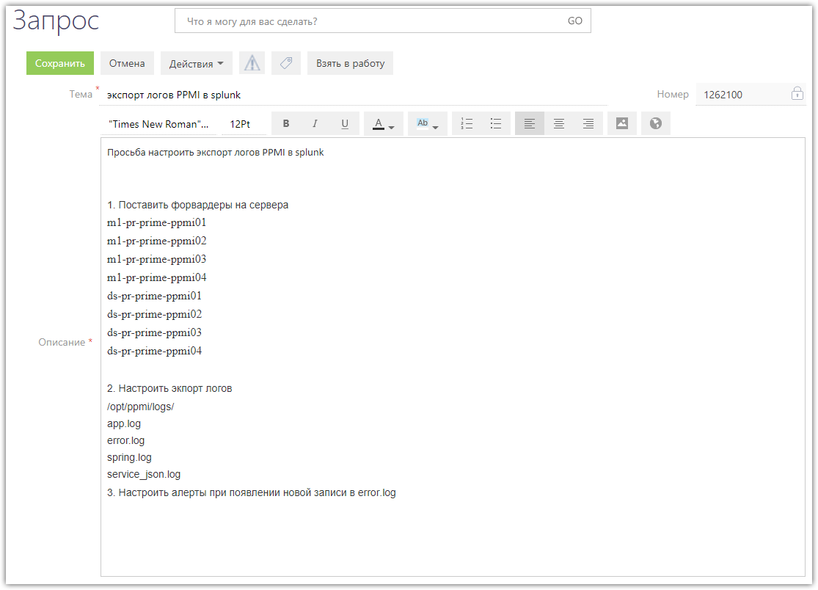

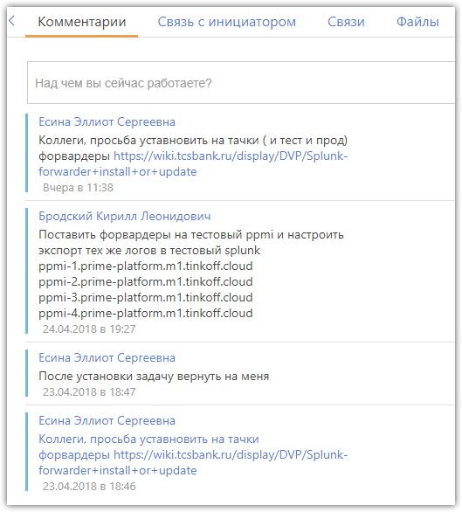
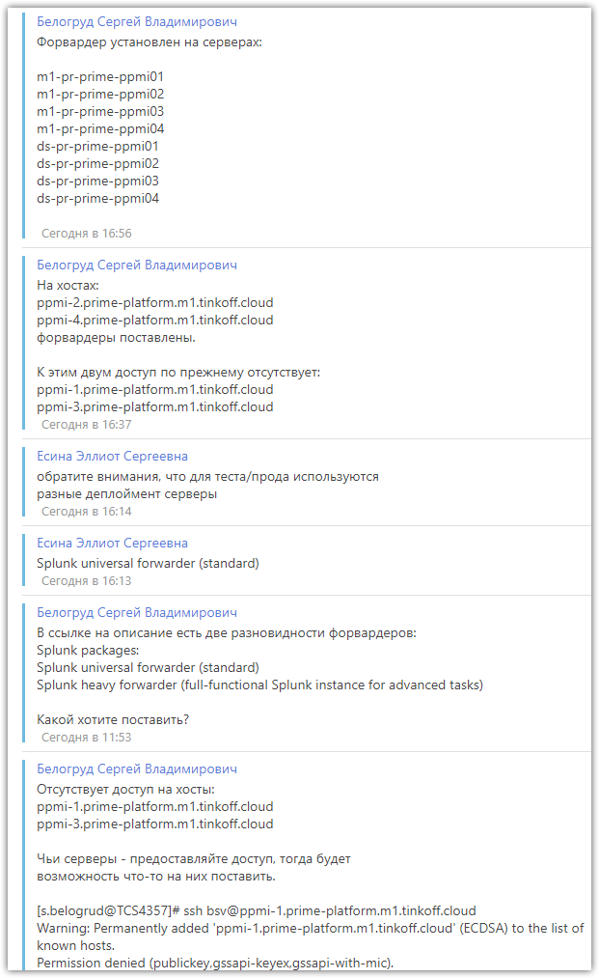

https://wiki.tcsbank.ru/pages/viewpage.action?spaceKey=DVP&title=Splunk-forwarder+install+or+update

Перейти к концу метаданных
- Создал(а) Aboltin Nikita Evgenevich0, редактировал(а) Efremov Mikhail Aleksandrovich фев 02, 2018
Переход к началу метаданных

Установка splunk-forwarder
Внимание!
- Добавление источников в Splunk prod и Splunk test производить только по согласованию со splunk-adm@tinkoff.ru!
- Splunk test (точка входа: vm-splunktest.tcsbank.ru) - это Спланк для непрерывной подготовки приложений к релизам, а не среда для тренировки
- Если кому-то нужен спланк на предемет пощупать фичи поиска/приложений/заливки данных, действовать следует так:
  - Развернуть на своих машинах инстанс спланка (рекомендуемый вариант). Дистрибутив доступен ниже (Splunk heavy forwarder). Инструкция по установке вот: http://docs.splunk.com/Documentation/Splunk/7.0.1/Installation/Whatsinthismanual
  - Обратиться к splunk-adm с просьбой сделать тестовый инстанс

Splunk packages
Splunk universal forwarder (standard)
- http://nexus-new.tcsbank.ru/repository/dist/splunk/splunkforwarder-7.0.1-2b5b15c4ee89-linux-2.6-amd64.deb (for Debian/Ubuntu)
- http://nexus-new.tcsbank.ru/repository/dist/splunk/splunkforwarder-7.0.1-2b5b15c4ee89-linux-2.6-x86_64.rpm (for Centos/Redhat)
- http://nexus-new.tcsbank.ru/repository/dist/splunk/splunkforwarder-7.0.1-2b5b15c4ee89-x64-release.msi (for Windows)
Splunk heavy forwarder (full-functional Splunk instance for advanced tasks)
- http://nexus-new.tcsbank.ru/repository/dist/splunk/splunk-7.0.1-2b5b15c4ee89-linux-2.6-amd64.deb (for Debian/Ubuntu)
- http://nexus-new.tcsbank.ru/repository/dist/splunk/splunk-7.0.1-2b5b15c4ee89-linux-2.6-x86_64.rpm (for Centos/Redhat)
- http://nexus-new.tcsbank.ru/repository/dist/splunk/splunk-7.0.1-2b5b15c4ee89-x64-release.msi (for Windows)

Linux:
- Скачать, а затем установить/обновить на необходимом хосте:
- RedHat
- sudo -i && rpm -ivh splunkforwarder{version package}.rpm
- Debian
- sudo -i && dpkg -i splunkforwarder{version package}.deb
- Согласие с лицензией, а также добавление скрипта загрузки и добавление в автозагрузку при старте системы:
- /opt/splunkforwarder/bin/splunk start --accept-license && /opt/splunkforwarder/bin/splunk enable boot-start && chkconfig --add splunk
- Rergister forwarder on the deploy server (you must select production or testing environment (only one value)):
- Credentials
- login: admin, password: changeme
- Send data to splunk (production)
- /opt/splunkforwarder/bin/splunk set deploy-poll m1-splunk-nidx01.tcsbank.ru:8089
- Send data to splunktest (testing)
- /opt/splunkforwarder/bin/splunk set deploy-poll vm-splunktest-idx01.tcsbank.ru:8089

Добавление файлов или директорий для мониторинга
Для добавления источников следует написать на адрес splunk-adm <splunk-adm@tinkoff.ru> c описание пути для логгирования и адрес хоста (ipv4 address, hostname (fqdn)) с которого будет производится мониторинг.

Переустановка форвардера на Linux в одну строку
service splunk stop; yum remove -y splunkforwarder ; rm -rf /etc/init.d/splunk /opt/splunkforwarder; rpm -ivh /home/ema/splunkforwarder-6.4.0-f2c836328108-linux-2.6-x86_64.rpm ; /opt/splunkforwarder/bin/splunk start --accept-license && /opt/splunkforwarder/bin/splunk enable boot-start && chkconfig --add splunk; /opt/splunkforwarder/bin/splunk set deploy-poll vm-splunktest-idx01.tcsbank.ru:8089 -auth "admin:changeme"; service splunk restart

# An important thing are below:

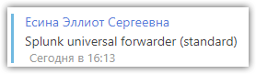

#
# To install splunk forwarder at test server, do like follow.
#
[s.belogrud@TCS4357]# ssh bsv@ppmi-4.prime-platform.m1.tinkoff.cloud

[root@ppmi-4 ~]# cat /etc/redhat-release
CentOS Linux release 7.4.1708 (Core)
[root@ppmi-4 ~]#

#
# Doing like this. It’s feet for “standard splunk universal forwareder”
yum -y localinstall http://nexus-new.tcsbank.ru/repository/dist/splunk/splunkforwarder-7.0.1-2b5b15c4ee89-linux-2.6-x86_64.rpm

#
# Or we can do like follow.
[root@ppmi-4 ~]# curl -O http://nexus-new.tcsbank.ru/repository/dist/splunk/splunkforwarder-7.0.1-2b5b15c4ee89-linux-2.6-x86_64.rpm
% Total % Received % Xferd Average Speed Time Time Time Current
Dload Upload Total Spent Left Speed
100 20.6M 100 20.6M 0 0 48.8M 0 --:--:-- --:--:-- --:--:-- 48.9M
[root@ppmi-4 ~]#
[root@ppmi-4 ~]# yum localinstall splunkforwarder-7.0.1-2b5b15c4ee89-linux-2.6-x86_64.rpm

/opt/splunkforwarder/bin/splunk start --accept-license && /opt/splunkforwarder/bin/splunk enable boot-start && chkconfig --add splunk

#
# This is for test servers.
/opt/splunkforwarder/bin/splunk set deploy-poll vm-splunktest-idx01.tcsbank.ru:8089

#
# In case I need reinstall splunk forwarder.
# There are follow steps need to do.
#

[root@ppmi-4 ~]# service splunk stop; yum remove -y splunkforwarder ; rm -rf /etc/init.d/splunk /opt/splunkforwarder

#
# It’s need to finish all not finished process.
# If not to finish it - we will come across on busy port 8089, when we will attempt to install splunk forwarder.
#
[root@ppmi-4 ~]# netstat -nlptu | grep -ie 8089
tcp 0 0 0.0.0.0:8089 0.0.0.0:* LISTEN 2141/splunkd
[root@ppmi-4 ~]# ps axu | grep splunk[d]
root 2141 0.1 1.5 220004 127052 ? Sl 16:36 0:02 splunkd -p 8089 restart
root 2145 0.0 0.1 72060 11772 ? Ss 16:36 0:00 [splunkd pid=2141] splunkd -p 8089 restart [process-runner]
[root@ppmi-4 ~]# kill -9 2141
[root@ppmi-4 ~]# ps axu | grep splunk[d]
[root@ppmi-4 ~]#

#
# Here are two commnads combined in two line. We use previously downloaded rpm package.
#
[root@ppmi-4 ~]# rpm -ivh ./splunkforwarder-7.0.1-2b5b15c4ee89-linux-2.6-x86_64.rpm ; /opt/splunkforwarder/bin/splunk start --accept-license && /opt/splunkforwarder/bin/splunk enable boot-start && chkconfig --add splunk; /opt/splunkforwarder/bin/splunk set deploy-poll vm-splunktest-idx01.tcsbank.ru:8089 -auth "admin:changeme"; service splunk start
warning: ./splunkforwarder-7.0.1-2b5b15c4ee89-linux-2.6-x86_64.rpm: Header V4 DSA/SHA1 Signature, key ID 653fb112: NOKEY
Preparing... ################################# [100%]
Updating / installing...
1:splunkforwarder-7.0.1-2b5b15c4ee8################################# [100%]
complete

This appears to be your first time running this version of Splunk.

Splunk> Take the sh out of IT.

Checking prerequisites...
Checking mgmt port [8089]: open
Creating: /opt/splunkforwarder/var/lib/splunk
Creating: /opt/splunkforwarder/var/run/splunk
Creating: /opt/splunkforwarder/var/run/splunk/appserver/i18n
Creating: /opt/splunkforwarder/var/run/splunk/appserver/modules/static/css
Creating: /opt/splunkforwarder/var/run/splunk/upload
Creating: /opt/splunkforwarder/var/spool/splunk
Creating: /opt/splunkforwarder/var/spool/dirmoncache
Creating: /opt/splunkforwarder/var/lib/splunk/authDb
Creating: /opt/splunkforwarder/var/lib/splunk/hashDb
New certs have been generated in '/opt/splunkforwarder/etc/auth'.
Checking conf files for problems...
Done
Checking default conf files for edits...
Validating installed files against hashes from '/opt/splunkforwarder/splunkforwarder-7.0.1-2b5b15c4ee89-linux-2.6-x86_64-manifest'
All installed files intact.
Done
All preliminary checks passed.

Starting splunk server daemon (splunkd)...
Done
[ OK ]
Init script installed at /etc/init.d/splunk.
Init script is configured to run at boot.
Configuration updated.
Starting splunk (via systemctl): [ OK ]
[root@ppmi-4 ~]#

#
# This is a way to install splunk forwarder at production server.

[s.belogrud@TCS4357]# ssh bsv@m1-pr-prime-ppmi01

[root@m1-pr-prime-ppmi01 ~]# cat /etc/redhat-release
CentOS Linux release 7.4.1708 (Core)
[root@m1-pr-prime-ppmi01 ~]# yum -y localinstall http://nexus-new.tcsbank.ru/repository/dist/splunk/splunkforwarder-7.0.1-2b5b15c4ee89-linux-2.6-x86_64.rpm

[root@m1-pr-prime-ppmi01 ~]# /opt/splunkforwarder/bin/splunk start --accept-license && /opt/splunkforwarder/bin/splunk enable boot-start && chkconfig --add splunk

This appears to be your first time running this version of Splunk.

Splunk> Take the sh out of IT.

Checking prerequisites...
Checking mgmt port [8089]: open
Creating: /opt/splunkforwarder/var/lib/splunk
Creating: /opt/splunkforwarder/var/run/splunk
Creating: /opt/splunkforwarder/var/run/splunk/appserver/i18n
Creating: /opt/splunkforwarder/var/run/splunk/appserver/modules/static/css
Creating: /opt/splunkforwarder/var/run/splunk/upload
Creating: /opt/splunkforwarder/var/spool/splunk
Creating: /opt/splunkforwarder/var/spool/dirmoncache
Creating: /opt/splunkforwarder/var/lib/splunk/authDb
Creating: /opt/splunkforwarder/var/lib/splunk/hashDb
New certs have been generated in '/opt/splunkforwarder/etc/auth'.
Checking conf files for problems...
Done
Checking default conf files for edits...
Validating installed files against hashes from '/opt/splunkforwarder/splunkforward er-7.0.1-2b5b15c4ee89-linux-2.6-x86_64-manifest'
All installed files intact.
Done
All preliminary checks passed.

Starting splunk server daemon (splunkd)...
Done
[ OK ]
Init script installed at /etc/init.d/splunk.
Init script is configured to run at boot.
[root@m1-pr-prime-ppmi01 ~]#

#
# This is for production servers.
[root@m1-pr-prime-ppmi01 ~]# /opt/splunkforwarder/bin/splunk set deploy-poll m1-splunk-nidx01.tcsbank.ru:8089
Splunk username: admin
Password:
Configuration updated.
[root@m1-pr-prime-ppmi01 ~]#

